**Social Service in the Context of the 78th Anniversary of Central Java Province**

Siti Wulandari,

[231500020@almaata.ac.id](mailto:231500020@almaata.ac.id)

Master of Islamic Education Almaata Yogyakarta

Abstract:

Social service activities in commemoration of the 78th Anniversary of Central Java Province in Tengki Village, Bantarkawung District, Brebes Regency, have succeeded in having a positive impact on the welfare of the community. This program includes the distribution of free basic necessities, the sale of cheap basic necessities, free health checks, and the sale of appropriate clothing. The results of the activity showed high enthusiasm from the community, with more than 3,855 clothes sold, especially in the categories of women's clothes and children's clothing. In addition, 150 free food packages and 700 cheap food packages were successfully distributed, and more than 500 residents took advantage of free health checkup services. This program also supports the government's efforts to prevent stunting through the distribution of eggs for families with toddlers. This activity not only eases the economic burden of residents, but also raises awareness of the importance of health and nutritional fulfillment. The success of this activity shows the importance of collaboration between the government and the community in improving the quality of life, as well as providing recommendations to increase the scope and effectiveness of the program in the future.

Keywords: Social Service, Stunting Prevention, Nutrition Fulfillment.

**INTRODUCTION**

The 78th Anniversary of Central Java Province is an important momentum to reflect on the development journey while making a real contribution to the community. In this commemoration, various social activities are held as a form of government concern for the welfare of the community. One of the activities that was highlighted was a social service held in Tengki Village, Bantarkawung District, Brebes Regency (Semarang: 2024).

Tengki Village, located in the hilly area of Brebes, is known as an agrarian area with great potential in agriculture. However, the challenges of public welfare and health are still a major concern. Therefore, social service activities that include the distribution of free basic necessities, health checks, the sale of cheap basic necessities, the sale of appropriate clothing, and the distribution of eggs for stunting prevention are strategic steps to improve the quality of life of the village community.

This activity is expected to have a significant positive impact. In addition to easing the economic burden, this program also aims to increase public awareness of the importance of a healthy lifestyle and the fulfillment of child nutrition as an effort to prevent stunting. Through this approach, the government and various parties involved show a real commitment to building a more prosperous and inclusive Central Java (Jakarta: 2024).

**METHOD**

The method used in the implementation of social service activities in Tengki Village is a qualitative descriptive approach. This method aims to describe in detail the process of implementing activities and their impact on the local community. The location of the activity was chosen based on data that shows that Tengki Village, Bantarkawung District, Brebes Regency, is one of the areas with a level of welfare that needs to be improved. The subject of the activity involves village communities, especially vulnerable groups such as underprivileged families, pregnant women, and toddlers who need special attention in fulfilling nutrition and health (BPS Brebes Regency, 2023).

Data collection is carried out through three main techniques, namely observation, interviews, and documentation. Observation is used to directly monitor the process of implementing activities, such as the distribution of basic necessities, health checks, and egg distribution for stunting prevention. Interviews were conducted with community leaders, village officials, and beneficiaries to explore their views on the impact of this activity. In addition, documentation in the form of photos, videos, and activity notes is also collected as supporting materials for analysis (Sugiyono, 2020).

The implementation of the activity is divided into three main stages. First, the planning stage involves local governments, related agencies, and local communities to prepare agendas, logistics, and budget allocations. Second, the implementation stage where activities are carried out in the field with the active participation of the community. Third, the evaluation stage to measure the success of the program, both in terms of quantitative achievements such as the number of beneficiaries, and qualitatively through community responses and experiences (Ministry of Social Affairs of the Republic of Indonesia, 2023).

The collected data is analyzed descriptively to provide a comprehensive picture of the implementation and results of the activity. Quantitative analysis was conducted to calculate the number of beneficiaries and the scope of activities, while qualitative analysis was used to understand the social impact felt by the community. This approach is expected to provide a comprehensive evaluation of the social service program in Tengki Village.

**RESULTS AND DISCUSSION**

**ACTIVITY RESULTS**

Social service activities in the context of the 78th Anniversary of Central Java Province in Tengki Village, Bantarkawung District, Brebes Regency, have been running well and received high enthusiasm from the local community. The results of this activity cover various aspects, including the sale of appropriate clothing, which is one of the main programs.

* **Distribution of basic necessities:** A total of 150 free basic food packages were given to underprivileged residents. This activity helps ease the burden on the community, especially in meeting daily basic needs.
* **Free Health Checkups:** More than 500 residents avail of health check-up services, including blood pressure checks, blood sugar levels, and medical consultations. The results showed that some residents needed a referral for further treatment.
* **Cheap Grocery Sales:** A total of 700 basic food packages are sold at affordable prices, which directly provide access to basic necessities at a lower price than the market price.
* **Appropriate Clothing Sales:** More than 3855 clothes were sold in the categories of men's, women's, children's clothing, and others, with the following details:
  + Men's clothes: 975 units
  + Women's clothes: 1100 units
  + Children's clothing: 980 units
  + Others: 800 units

**DISCUSSION**

The sale of appropriate clothing received a positive response from the community. The high enthusiasm of the residents can be seen from the number of clothes sold. Women's and children's clothing is the most popular category, showing that there is a significant need for this category in the people of Tengki Village. This is in line with local demographic data that shows the high population of families with young children in the region (Brebes Central Statistics Agency, 2023).

In addition, the distribution of basic necessities and health checks also provide direct benefits. This program supports the government's efforts to improve public welfare and health. This effort is in line with the national program to improve nutrition and reduce stunting rates, especially through the distribution of eggs to families with toddlers (Ministry of Health of the Republic of Indonesia, 2024).

The following image shows the atmosphere of the sale of appropriate clothing:

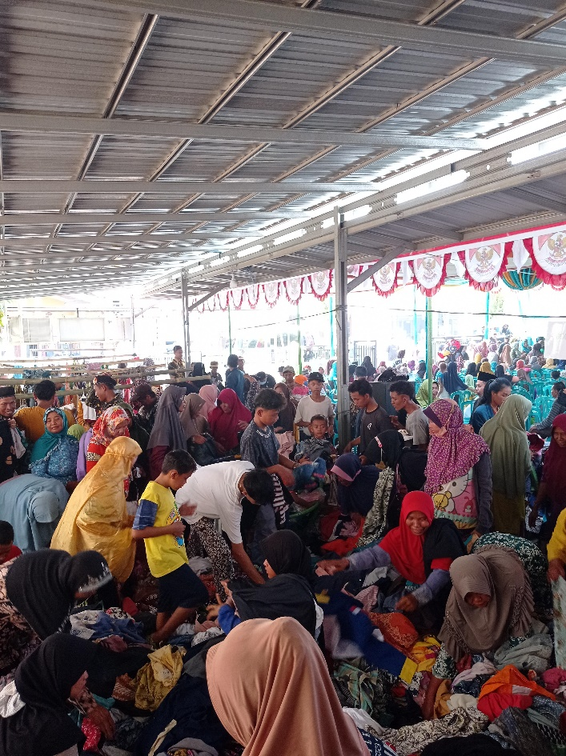

1.1 Sales of Wearable Clothing

The sale of appropriate clothes is part of the social service program in the context of the 78th Anniversary of Central Java Province. It appeared that the community gathered in an open location equipped with a roof, with a typical decoration order such as red and white flags, showing the atmosphere of celebration.

The residents were busy choosing appropriate clothes that were sold at affordable prices. The enthusiasm of the community is very high, especially because this activity provides access to decent clothes at pocket-friendly prices. This activity not only helps the community get clothing needs at a low cost, but also is part of the efforts of the government and the committee to support the welfare of villagers, especially in the Tengki Village area, Bantarkawung District, Brebes Regency.

The program also reflects the spirit of mutual cooperation and sustainability, where the proceeds from the sale are used to support other social activities, such as free health check-ups and the distribution of basic necessities. The atmosphere seen in the picture indicates the active involvement of the community in taking advantage of this moment of social service.

The table below provides a data visualization of the number of clothes sold by category:

Here is a table of the number of clothes sold by category:

|  |  |
| --- | --- |
| Clothing Categories | Number Sold (units) |
| Men's Clothes | 975 |
| Women's Clothes | 1100 |
| Children's Clothing | 980 |
| Others | 800 |

The table above presents data on the sale of appropriate clothing by category during social service activities in Tengki Village. Here is the explanation:

1. **Men's ClothesA total of 975 units of** men's clothes were sold. This shows that although there is a demand for men's clothing, the number is comparatively smaller compared to other categories. This category meets the basic needs of men in society.
2. **Women's ClothingWith 1100 units** sold, this category recorded the highest sales. This high demand shows that women's clothing has a wider variety of needs, ranging from everyday wear to special needs.
3. **Children's Clothing sold as many as 980 units**, this category is the second highest. This is in line with the high number of families with small children in Tengki Village, so that children's clothing is an urgent need for many households.
4. **MiscellaneousA total of 800 units** were sold in this category, which includes clothing or other items outside of the three main categories. Although this number is smaller, this category is still important to meet the diverse needs of society.

**Conclusion**:

Social service activities in the context of the 78th Anniversary of Central Java Province in Tengki Village have been running successfully, bringing a significant positive impact to the local community. One of the main programs, the sale of appropriate clothing, recorded sales of more than 3,855 units. The women's and children's clothing category has the highest sales figures, reflecting the high demand in this segment. In addition, the distribution of 150 free food packages and the sale of 700 cheap food packages helped ease the economic burden of underprivileged residents. The free health check-up service attended by more than 500 residents also raises awareness of the importance of health, while the egg distribution program for families with toddlers supports stunting prevention efforts. The high enthusiasm of the community in each activity shows the success of this event in improving the welfare and involvement of the local community. In the future, it is recommended that the number of items provided, especially women's and children's clothing, be increased. In addition, the duration and scope of the activity area can be expanded to reach more beneficiaries. Further evaluation and innovation are needed to ensure that the program can continue to develop and provide maximum benefits to the community.

**References**:

Central Java Provincial Government, *Commemoration of the 78th Anniversary of Central Java Province* (Semarang: 2024).

The Central Statistics Agency of Brebes Regency, *Tengki Village Profile*, accessed 2023.

Ministry of Health of the Republic of Indonesia, *Stunting Prevention Strategy through Family Nutrition Fulfillment* (Jakarta: 2024).

Central Statistics Agency of Brebes Regency. (2023). *Profile of Tengki Village*.

Sugiyono. (2020). *Qualitative, Quantitative, and R&D Research Methods*. Bandung: Alfabeta.

Ministry of Social Affairs of the Republic of Indonesia. (2023). *Guidelines for the Implementation of Social Programs*.

Ministry of Health of the Republic of Indonesia. (2024). *Stunting Prevention Strategies through Family Nutrition Fulfillment*.

Central Java Provincial Government. (2024). *Report on the 78th Anniversary of Central Java*.

Central Statistics Agency of Brebes Regency. (2023). *Tengki Village Demographic Data*.