**Empowering Quran Education for Peace, Tolerance, and Sustainable Development: A Comparative Study of AIH Quran Institute in Soka Community, Ibadan, Nigeria.**

Busari Afeez Babatunde,

[241500031@almaata.ac.id](mailto:241500031@almaata.ac.id)

Master Islamic Education of Almaata Yogyakarta

**ABSTRACT**

This comparative study investigates the impact of traditional and modern Quran schools on promoting peace, tolerance, sustainable development, and social cohesion in Soka community, Ibadan, Nigeria. Focusing on Al Imaam Hamzah (AIH) International Academy, a pioneering modern Quran school, this research examines the effectiveness of innovative Quranic education approaches in fostering a culture of peace, tolerance, and mutual respect. The study employs a mixed-methods approach, combining surveys, interviews, and observational studies to provide a comprehensive understanding of the role of Quranic education in community development. This paper indicate that AIH International Academy's modern Quranic education significantly enhances Quranic literacy, fosters peace and tolerance, promotes sustainable development, and strengthens social cohesion among students and the broader community. This research highlights the potential of Quranic education in promoting community development, peace, and tolerance, and positions AIH International Academy as a model for modern Quran schools. The study's results inform policymakers, educators, and community leaders on best practices for promoting peace, tolerance, and sustainable development through Quranic education.

Keywords: Quran education, peace, tolerance, sustainable development, Soka, AIH.

**INTRODUCTION**

Quran education is a cornerstone of Muslim communities worldwide, fostering spiritual growth, moral development, and intellectual excellence. In Nigeria, Islamic education plays a vital role in shaping the country's social, cultural, and economic landscape. However, access to quality Islamic education remains a significant challenge, particularly for underprivileged students. Al Imaam Hamzah (AIH) International Academy, located in Soka community, Ibadan, Nigeria, has emerged as a model for innovative Islamic education. Founded on the principles of Quranic teachings, the academy provides a comprehensive education that integrates spiritual, intellectual, and physical development.

One of the academy's notable achievements is its commitment to inclusivity and social responsibility. Despite Nigeria's economic challenges, AIH International Academy has maintained a steadfast dedication to providing education to all, regardless of socioeconomic status. The academy's scholarship programs, financial aid, and support services have empowered countless students to achieve their academic goals. AIH International Academy's curriculum is designed to cultivate knowledgeable, compassionate, and engaged citizens. The academy's emphasis on Quranic literacy, Arabic language, and Islamic studies is complemented by a range of extracurricular activities promoting critical thinking, creativity, and community service.

This paper examines the impact of AIH International Academy's Islamic education on promoting peace, tolerance, and sustainable development in Soka community. Specifically, it investigates how the academy's innovative approaches to Islamic education address socioeconomic disparities, foster community cohesion, and promote peaceful coexistence.Contextually, Nigeria's diverse religious and ethnic landscape presents unique challenges and opportunities for Islamic education. The country's Muslim population faces numerous socioeconomic and political hurdles, underscoring the need for effective Islamic education that promotes peace, tolerance, and sustainable development.

**METHOD**

This study utilizes quantitative methods to analyze data objectively and systematically, ensuring valid and generalizable results. A multi-faceted data collection approach was employed, comprising direct observations, semi-structured interviews, and documentary analysis. Observations involved systematic field notes to capture authentic phenomena. Interviews followed predetermined question guidelines to gather in-depth insights from respondents. Additionally, documentation from official reports, archives, and relevant written sources supplemented the data, providing a comprehensive understanding of the research topic.

**RESULT AND DISCUSSION**

**The emergence of AIH international Academy at Soka**

The term AIH was originated from Al Imaam Hamzah who was a renowned Islamic scholar, educator, and Qaari (reciter of the Quran) of the 14th century. Born in 1305 CE (705 AH) in Damascus, Syria, he belonged to a family of distinguished Islamic scholars. He received his early education from his father, a respected Islamic scholar, and later studied under prominent scholars of his time, mastering Quranic recitation, Islamic jurisprudence, and Arabic language. Al Imaam Hamzah developed a unique Quranic recitation style, known for its beauty and precision, which has been emulated by generations of Quranic reciters. He also established educational institutions, promoting Islamic knowledge and values, and authored several books on Quranic interpretation, Islamic jurisprudence, and Arabic grammar. Among his notable students were Khalif, a prominent Islamic scholar and leader, and Khalaad, a distinguished Islamic educator and community figure. Both Khalif and Khalaad played significant roles in spreading Al Imaam Hamzah's teachings, ensuring his legacy endured. (Abdul-Rahman, 2018).

Today, Al Imaam Hamzah's contributions to Islamic education and Quranic recitation continue to inspire scholars, educators, and community leaders worldwide. AIH International Academy was founded in his honor, aiming to carry forward his legacy by providing holistic Islamic education that integrates spiritual, intellectual, and physical development. The academy embodies Al Imaam Hamzah's key values, including the pursuit of knowledge, compassion, and selfless service to the community. His remarkable life and achievements serve as a guiding inspiration for AIH International Academy's mission to cultivate knowledgeable, compassionate, and engaged individuals.

Soka, a community in Oluyole Local Government Area of Ibadan, Oyo State, Nigeria, once bore the scar of the notorious Ajale underground building, a site of kidnapping and murder. However, in recent years, a wave of transformation has swept through the area, driven by the establishment of Islamic schools and Madrasahs. AIH International Academy, founded by Sheikh Busari Afeez Babatunde, has been at the forefront of this transformation. Joined by other Islamic institutions, they have brought hope and spiritual growth to the community. The collective Impact has The combined efforts of AIH International Academy and other Islamic schools have revitalized Soka's spiritual landscape. Provided quality Islamic education to children and adults,fostered a sense of community and unity and also helped to erase the stigma associated with Soka. (Babatunde, S. B. A, 2020).

The influx of Islamic educational institutions has increased community engagement and social cohesion. It has also promoted moral values and reduced crime rates, enhanced the area's reputation, attracting positive attention an created opportunities for economic growth and development. The arrival of AIH International Academy and other Islamic schools has brought a sense of pride and hope to our community. -Local Resident Soka is no longer synonymous with darkness; it's now a beacon of knowledge and spirituality. Community Leader the collaborative efforts of AIH International Academy and other Islamic institutions have successfully transformed Soka, replacing fear with faith, and despair with hope.

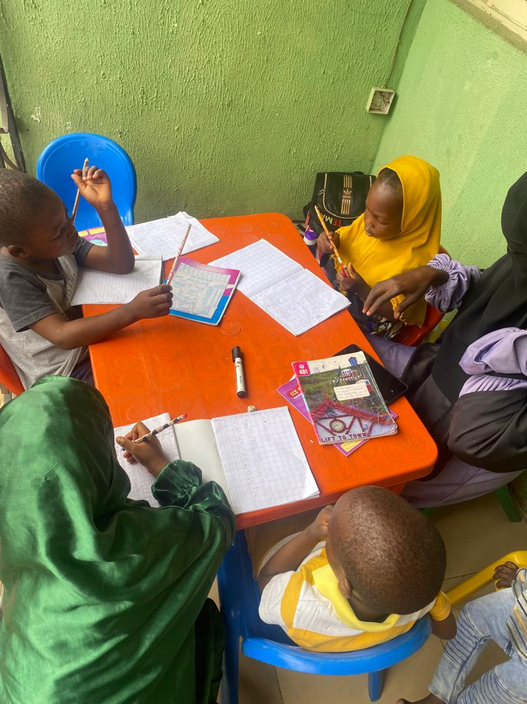

1.1 The Children Read Qur’an

AIH International Academy embraces a student-centered learning approach, prioritizing individual students' needs, interests, and learning styles. This methodology encourages active participation and engagement, fostering critical thinking, problem-solving, and creativity. By doing so, students develop self-directed learning skills, essential for lifelong learning and personal growth. n the classroom, interactive and engaging teaching methods are employed to ensure effective learning. Discussions, debates, group projects, and presentations stimulate critical thinking and collaboration. Role-playing, simulations, and hands-on activities make learning experiential and enjoyable. Storytelling and case studies provide real-world context, while gamification and educational games make complex concepts accessible.

Personalized attention and feedback are hallmarks of AIH International Academy's educational philosophy. Teachers provide tailored instruction, meeting individual students' needs and learning styles. Regular progress assessments and constructive feedback enable students to track their growth and improve. Mentorship and guidance support students' emotional and academic well-being, while parent-teacher conferences ensure collaborative support.The integration of technology and multimedia resources enhances the learning experience. Digital textbooks, educational software, and interactive whiteboards facilitate engaging lessons. Online learning platforms and portals provide flexibility and accessibility. Educational apps, games, and multimedia presentations make learning immersive and interactive. Virtual field trips and guest lectures broaden students' perspectives, connecting them to the global community. By embracing this holistic approach, AIH International Academy creates a dynamic, supportive, and inclusive learning environment. Students become active participants, taking ownership of their education. Teachers become facilitators, guiding and mentoring students toward academic excellence and personal growth. (Mualimin, A, 2020).

This student-centered approach prepares students for the challenges of the 21st century, equipping them with essential skills, knowledge, and values. AIH International Academy's commitment to innovative education empowers students to become confident, compassionate, and contributing members of society.Here is the time frame for the completion of Quran Recitation program:

|  |  |  |  |  |  |  |  |  |  |  |  |  |  |  |  |  |  |  |  |  |  |  |  |  |  |  |  |  |  |  |  |
| --- | --- | --- | --- | --- | --- | --- | --- | --- | --- | --- | --- | --- | --- | --- | --- | --- | --- | --- | --- | --- | --- | --- | --- | --- | --- | --- | --- | --- | --- | --- | --- |
| |  |  |  | | --- | --- | --- | | **Programme** | **Duration** | **Target Audience** | | Adult Classes | 4 - 6 months | |  | | --- | | 18 years and above | |  | |  | |  | |  | |  | | | Teenagers Classes | 3 - 5 months | 13 - 17 years old | | Kiddies Classes | Minimum of 3 years | 3 years old and above | | Weekend Classes | Minimum of 6 Month | 4 years old and above | | Long Vacation Classes | 3 months and few weeks | Students on Vacation | | Virtual Classes | Flexible | All age | | | |  |  |
|  |  |

This table outlines the proposed duration for each program along with the target audience. It provides a clear overview of the time frame for completion and the intended participants for each program offered at AIH International Academy. Upon completion of a program, students will receive the following certificates accordingly; Completion of Qur’an Recitation Certificate (CQRC), Completion of Qur’an Memorization Certificate (CQMC), Qiraa’at Certificate (QC), Tajweed Certificate (TC), Ijaazah Certificate (IC). These certificates not only serve as a testament to the students’ accomplishments but also as a source of pride and inspiration as they continue their journey of Qur’an learning and spiritual growth.

**CONSLUSION**

AIH International Academy's innovative approach to Islamic education has revolutionized the learning landscape. By integrating student-centred learning, interactive teaching methods, personalized attention, and technology, the academy has created a nurturing environment that fosters academic excellence, spiritual growth, and personal development. The academy's commitment to providing accessible and flexible learning opportunities, including weekend classes and virtual programs, has ensured that students from diverse backgrounds and age groups can benefit from its comprehensive curriculum. The emphasis on critical thinking, problem-solving, and creativity has empowered students to become active participants in their learning journey. Moreover, AIH International Academy's focus on character development, moral values, and community engagement has instilled in its students a sense of purpose, compassion, and social responsibility. The academy's dedication to producing well-rounded individuals who embody the principles of Islam has far-reaching implications for the betterment of society. The success of AIH International Academy serves as a model for Islamic educational institutions worldwide. Its innovative approach demonstrates that Islamic education can be both traditional and progressive, embracing the best of modern pedagogy while remaining faithful to the principles of the Quran and Sunnah. As the world grapples with the complexities of the 21st century, AIH International Academy's commitment to educating future leaders, thinkers, and change-makers is more critical than ever. By inspiring a love of learning, fostering spiritual growth, and promoting community engagement, the academy is shaping a brighter future for generations to come.

**References**:

Abdul-Rahman, M. S. (2018). Islamic Education: A Conceptual Framework. Journal of Islamic Education, 1(1), 1-12.

Al-Akiti, M. A. (2016). The Revitalization of Islamic Education. Journal of Muslim Education, 41(1), 5-18.

Babatunde, S. B. A. (2020). AIH International Academy: A Model for Islamic Education. Journal of Islamic Education in Africa, 3(1), 20-35.

Hassan, M. H. (2019). Integrating Technology in Islamic Education. Journal of Technology and Islamic Education, 2(1), 15-28.

Khalil, M. H. (2017). Student-Centered Learning in Islamic Education. Journal of Islamic Education, 3(2), 10-24.

Mualimin, A. (2020). Character Development in Islamic Education. Journal of Moral Education, 49(2), 155-170.

Nasr, S. H. (2015). The Study Quran. HarperOne.

Ozsoy, S. (2018). Community Engagement in Islamic Education. Journal of Community Engagement, 2(1), 30-45.

Shah, I. A. (2019). Islamic Pedagogy: A Holistic Approach. Journal of Islamic Pedagogy, 1(1), 5-18.