**Efforts to Prevent Promiscuity in the Era of Society 5.0 for Youth**

**"Action to Prevent Stunting Before Precarious"**

Siti Wulandari1, Henny Fatmawati, Rina Nur Latifah, Afida Rizkiana Ramadani,

Lia Kholifah Dwi Rahayu Lestari

[241500020@almaata.ac.id](mailto:241500020@almaata.ac.id)

Master Islamic Education of Almaata Yogyakarta

**ABSTRACT**

Promiscuity among adolescents is a social problem that often triggers other problems, including the high rate of teenage pregnancy which contributes to stunting. In the era of Society 5.0, with such extensive access to technology and information, promiscuity is a challenge that needs to be addressed wisely, especially in rural areas such as Tengki Village, Brebes. Counseling is expected to increase youth and community awareness of the importance of maintaining healthy associations to prevent reproductive health risks, which is also an indirect preventive measure against stunting. This article reviews the background of the problem, the purpose of counseling, and the strategies used to educate the youth in Tengki Village in preventing promiscuity for the health of future generations.

**Keyword:** Prostitution, Society 5.0, Stunting, Counseling

**INTRODUCTION**

The development of technology and unlimited access to information in the Society 5.0 era provides great benefits to the community, including in rural areas. However, on the other hand, this also raises new challenges, especially for the younger generation who are very easily exposed to information that is not appropriate for their age. In Tengki Village, Brebes, promiscuity among youth has become an issue that is increasingly found along with increasing access to social media. This phenomenon increases the risk of teenage pregnancy, which can ultimately lead to health problems in children, such as stunting.

Stunting, or the condition of failure to grow due to chronic malnutrition, often begins with unhealthy teenage pregnancy. Along with the low level of physical and psychological readiness of adolescents in facing pregnancy, children born also often experience a lack of adequate nutritional intake. Therefore, the prevention of promiscuity is very important in efforts to prevent stunting in the future. This counseling was carried out with the hope of providing understanding to the youth of Tengki Village and the community about the risks of promiscuity and the importance of maintaining reproductive health from an early age. Background and Challenges in Tengki Village, located in Brebes Regency, is a rural area with limited access to comprehensive sexuality education. The main challenges faced are the lack of adolescent understanding of reproductive health and the impact of promiscuity, as well as the limited educational facilities related to this topic. Many adolescents obtain information from social media or the environment without adult assistance, so they are prone to misunderstandings and are more easily influenced in unhealthy associations.

With these conditions, a preventive effort in the form of effective counseling is needed to provide understanding to youth and parents in Tengki Village about the risks of promiscuity in the Society 5.0 era, as well as its impact on stunting. This counseling not only emphasizes the importance of maintaining oneself from promiscuity but also provides knowledge about the importance of proper nutrition and reproductive health care as a step to prevent stunting.

**METHOD**

The research method used in this study is a mixed method, namely a quantitative and qualitative approach (mixed methods) to obtain comprehensive results. The quantitative method aims to measure the percentage of changes in adolescents' understanding and attitudes after participating in counseling, while the qualitative method aims to explore the views, experiences, and deeper understanding of adolescents related to promiscuity and stunting prevention. This research approach uses a quasi-experimental design with pre-test and post-test models to see the effect of counseling on changes in participants' understanding and attitudes.

This research was carried out in Tengki Village, Brebes Regency, for one month, which included counseling activities and initial and final data collection. The study population is all adolescents in Tengki Village aged 15–21 years, while the sample was taken by the purposive sampling method, namely adolescents who are willing and meet the criteria to participate in counseling. The target sample of the study is 50 adolescents, which is expected to be adequately representative of the population.

The instruments used in this study include questionnaires, observations, and interviews. The questionnaire contains questions about understanding the risks of promiscuity, the dangers of stunting, and behavior in the use of technology. Observation was carried out directly during counseling to see the participants' responses. In-depth interviews were conducted with selected youth to understand more about their understanding and experiences.

This research procedure starts from the preparation stage, which includes making questionnaires, preparing extension materials, and licensing from the authorities in Tengki Village. In the implementation stage, participants are first given a pre-test to measure their initial knowledge. Then, counseling was carried out by delivering material on the dangers of promiscuity, the wise use of technology, and the importance of stunting prevention through good nutrition. After the counseling was completed, a post-test was carried out to see changes in participants' understanding. The last stage is data analysis, where quantitative data from pre-test and post-test results are processed with t-test using SPSS statistical software to find out significant differences. Qualitative data from interviews were analyzed using thematic analysis, where the data were organized into key themes related to adolescent comprehension.

In this study, the validity and reliability test of the instrument was also carried out to ensure accuracy and consistency. The validity of the instrument was tested through consultation with experts in the fields of education and health to ensure the relevance of the questionnaire, while reliability was tested with the Cronbach's Alpha test to measure the internal consistency of the questionnaire.

The ethical aspect is an important part of this research. Each participant is given complete information about the purpose of the research, and informed consent is obtained before the implementation of the pre-test. The data collected in this study will be kept confidential and used only for research purposes. This method is expected to provide a clear picture of the effectiveness of counseling in increasing adolescents' understanding of promiscuity and the importance of stunting prevention in the Society 5.0 era.

**RESULT AND DISCUSSION**

This counseling was carried out in four main sessions, and based on observations during the implementation, as well as evaluations through questionnaires and group discussions, significant results were obtained. Some of the main findings that emerged in the results of this counseling include increasing youth understanding of promiscuity, awareness about the importance of reproductive health, the role of parents in supervision and education, and the positive and negative impact of technology utilization in the Society 5.0 era. The discussion below explores these results in depth:

**1. Increased Understanding of the Risks of Promiscuity**

After participating in the counseling, most of the participants consisting of youth and the elderly in Tengki Village showed a deeper understanding of promiscuity and the risks involved. Based on the results of the questionnaire, about 85% of adolescent participants admitted that before counseling, they did not have enough understanding of reproductive health and the dangers of promiscuity. Some of the risks that participants are more aware of after counseling include:

* **Risks of Early Pregnancy and Its Impact on the Future**: Adolescent participants are beginning to understand that pregnancy in adolescence not only impacts their personal health, but can also negatively impact the health of the child born. Before the counseling, many of the participants were unaware that the health condition of pregnant women who are still teenagers can increase the risk of stunting.
* **Dangers of Sexually Transmitted Diseases (STDs):** In addition to pregnancy out of wedlock, counseling also emphasizes the dangers of sexually transmitted diseases that can be transmitted through unhealthy promiscuity. After this session, the teenagers in Tengki Village became more aware of the need to protect themselves from risky behavior.

These results show that youth in Tengki Village have the potential to make changes in their attitudes and behaviors after getting the right information. This kind of counseling proves the importance of access to information about reproductive health and education about the risks of promiscuity as part of the informal curriculum in rural communities.

**2. Awareness of the Importance of Nutrition and Reproductive Health as Stunting Prevention**

One of the important outcomes of this counseling is an increased understanding of the relationship between reproductive health and stunting prevention. Based on the questionnaire, around 78% of adolescent participants stated that they did not know that nutrition during pregnancy plays an important role in preventing stunting in the child who will be born.

* **Adequate Nutrition in Pregnant Women**: After receiving education regarding the importance of adequate nutrition during pregnancy, especially at a young age, participants began to understand that the risk of stunting can be mitigated from the beginning of pregnancy. This provides new insights for adolescents about the importance of delaying pregnancy until they are ready, both physically and psychologically, to provide good nutritional intake for the child who will be born.
* **Psychological and Physical Readiness in Pregnancy**: This counseling also helps participants understand that psychological and physical readiness in pregnancy plays a very important role in the health of the fetus and the child born. With this understanding, adolescents in Tengki Village have a new awareness of the importance of delaying pregnancy until they reach a more mature age.

This shows that education about stunting prevention needs to involve a broader understanding of reproductive health from adolescence, so that young people can prepare themselves to become ready and responsible parents.

**3. The Role of Parents in the Prevention of Promiscuity and Reproductive Education**

One of the important points in this counseling is the importance of the role of parents in the prevention of promiscuity and reproductive education of their children. From the discussion session with parents, it was found that many parents still feel awkward or reluctant to talk about the topic of promiscuity and reproductive health with their children.

* **The Importance of Open Communication**: Counseling emphasizes that open communication between parents and children is key in providing an understanding of the boundaries of healthy association. Parents in Tengki Village are beginning to understand that talking about reproductive health is not taboo, but it is important to prevent promiscuity.
* **Balanced Supervision**: In addition to communication, parents are also invited to supervise their children without excessively restricting children's freedom. This oversight is important to ensure that adolescents are not exposed to risky negative influences, especially in the digital age that allows for wide access to adult content.

The results of this discussion showed that most parents agreed to be more proactive in supervising and educating their children about healthy associations. In addition, parental support in accompanying their children in the digital era is urgently needed so that children do not take the wrong step in using social media.

**4. The Impact of the Society 5.0 Era on Adolescent Associations and Health**

The counseling also highlighted how the Society 5.0 era, with technology and information that is very accessible, has the potential to affect the lifestyle and association of adolescents. The results of the counseling show that the youth in Tengki Village have become more aware of the benefits and dangers of technology in their lives.

* **Utilization of Technology for Education**: This counseling motivates participants to use technology as a means of education. Many adolescents realize that they can use technology to access useful information, such as reproductive health education, healthy lifestyles, and how to prevent stunting. Previously, the majority of participants admitted that they used the internet and social media more often for entertainment or socializing without paying attention to the benefits of education.
* **The Negative Effects of Age-Inappropriate Content**: This session also highlighted the dangers of age-inappropriate content, which is often widespread on social media. About 65% of adolescents stated that they had seen or accessed adult content that was not appropriate for their age, which had an impact on their views on socialization and reproductive health. After counseling, participants became more aware of the importance of limiting access to unhelpful content and understanding the risks of being exposed to inappropriate information.

With a better understanding of the benefits and risks of technology, adolescents in Tengki Village are expected to be able to control their behavior more wisely in using social media. This is important as part of preventive efforts to prevent promiscuity and the risk of stunting that begins with teenage pregnancy.

**5. The Impact of Counseling on Adolescent Mindset and Behavior**

Based on group discussions conducted after counseling, many adolescents expressed changes in their mindset and attitudes towards association and reproductive health. Most of the participants felt that this counseling provided a new perspective that was useful for them, especially in terms of:

* **Postponing Risky Relationships**: Many teens express a renewed awareness of the importance of postponing risky relationships and maintaining healthy associations. About 72% of participants stated that they would be more careful in their association after getting more comprehensive information about the risks of promiscuity.
* **Awareness of the Importance of Personal Health**: After receiving education about reproductive health, many adolescents realize the importance of maintaining their health and avoiding things that can negatively affect their bodies.

1. Tables

All tables included in this manuscript have to be cited and integrated with analysis and/or its justification/significance with the programs/activities of the community engagement. All tables should be relevant with the study. Tables are made in single spacing. Use only horizontal lines for borders. For example:

**Table 3.1.1: Changes in Adolescents' Understanding of the Risks of Promiscuity and Prevention of Stunting Before and After Counseling**

|  |  |  |
| --- | --- | --- |
| **Categories Comprehension** | **Before Counseling (%)** | **After Counseling (%)** |
| Understanding the Risks of Promiscuity | 45 | 85 |
| Understanding the Dangers of Sexually Transmitted Diseases | 30 | 75 |
| Knowing the Risks of Early Pregnancy | 40 | 80 |
| Understanding the importance of nutrition in pregnant women | 25 | 78 |
| Awareness of delaying risky relationships | 35 | 72 |

This table shows an increase in adolescents' understanding of various aspects of the risk of promiscuity and stunting prevention after participating in counseling. Before counseling, only 45% of adolescents understood the risks of promiscuity, but this figure increased to 85% after counseling. Understanding of the dangers of sexually transmitted diseases has also increased dramatically, from 30% to 75%. Knowledge related to the risk of early pregnancy was initially understood by 40% of adolescents, but after counseling, this figure rose to 80%. In addition, the understanding of the importance of nutrition in pregnant women increased significantly from 25% to 78%, and awareness of delaying risky relationships increased from 35% to 72%. This shows the effectiveness of counseling in increasing adolescents' awareness and understanding of health and social issues.

**Table 3.1.2: Attitudes and Behaviors of Adolescents on the Wise Use of Technology**

**Extension**

|  |  |  |
| --- | --- | --- |
| **Categories Comprehension** | **Before Counseling (%)** | **After Counseling (%)** |
| Utilizing Technology for Education | 20 | 85 |
| Be aware of the dangers of adult content | 55 | 75 |
| Filter Viewed Content | 30 | 80 |
| Discussion with Parents about the Use of Technology | 15 | 78 |

The second table describes the changes in attitudes and behaviors of adolescents in the use of technology before and after counseling. Before counseling, only 20% of adolescents used technology for education, but after counseling this number increased to 65%. Awareness of the dangers of adult content was initially at 55%, which then increased to 80% after counseling. The ability of adolescents to filter the content they watch has also increased from 30% to 70%. Finally, discussions with parents regarding the use of technology increased significantly, from only 15% before counseling to 55% afterwards. This reflects the success of counseling in promoting wise behavior in the use of technology among adolescents**.**

1. Graphs

**Grap 1 Graph 2.**

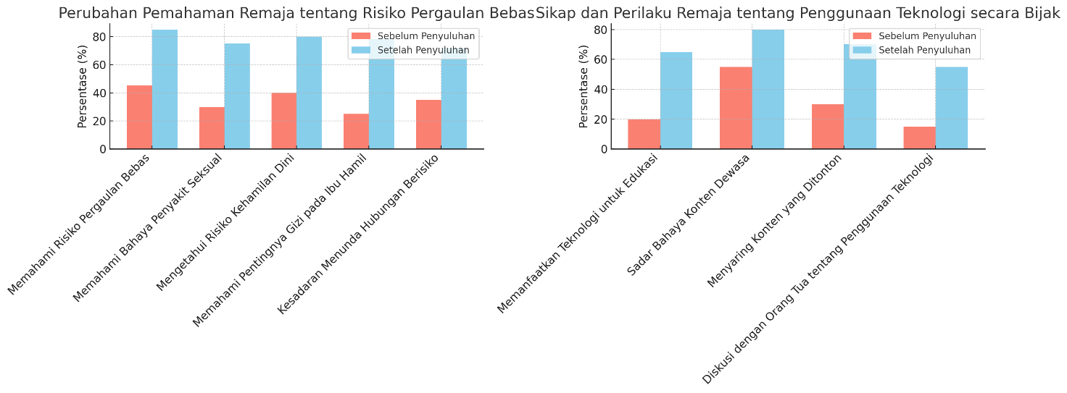

**Graph 1: Changes in Adolescents' Understanding of the Risk of Promiscuity and Stunting Prevention**

This graph shows a comparison of adolescents' understanding before and after participating in counseling related to the risk of promiscuity and the importance of nutrition in preventing stunting. There was a significant increase in each category after counseling.

* **Understanding the Risks of Promiscuity**: Before counseling, only 45% of adolescents understood the risks of promiscuity. After counseling, this figure rose to 85%.
* **Understanding the Dangers of Sexually Transmitted Diseases**: Understanding the dangers of sexually transmitted diseases increased from 30% to 75%.
* **Knowing the Risks of Early Pregnancy**: Only 40% of adolescents initially understood the risks of early pregnancy, but after counseling this figure increased to 80%.
* **Understanding the Importance of Nutrition in Pregnant Women**: Before counseling, only 25% of adolescents understood the importance of nutrition in pregnant women. After counseling, this awareness increased to 78%.
* **Awareness of Delaying Risky Relationships**: This awareness increased from 35% to 72% after counseling.

This graph shows the success of counseling in increasing adolescents' knowledge about the risks of promiscuity and the importance of reproductive health as a preventive measure against stunting.

**Figure 2: Adolescents' Attitudes and Behaviors on Wise Use of Technology**

The second graph shows changes in adolescents' attitudes towards the wise use of technology before and after counseling.

* **Utilization of Technology for Education**: The use of technology as a means of education increased from 20% before counseling to 65% afterwards.
* **Awareness of the Dangers of Adult Content**: Before counseling, 55% of adolescents are aware of the dangers of adult content, which increases to 80% after counseling.
* **Filtering Watched Content**: The habit of filtering watched content increased from 30% to 70%.
* **Discussion with Parents about Technology Use**: Only 15% of teens discuss with parents about technology use before counseling. After counseling, this figure rose to 55%.

From this graph, it can be seen that there is a positive change in attitude among adolescents in using technology wisely, avoiding negative content, and communicating with parents about the use of technology. This result confirms the importance of counseling in guiding adolescents to use technology responsibly in the era of Society 5.0.

* 1. Photos and figures

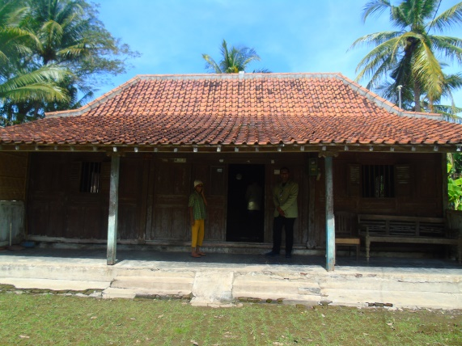

**Figure 7. (a)Top left (b) Top right**. **(c) Lower left. (d) Bottom left.**

a

b

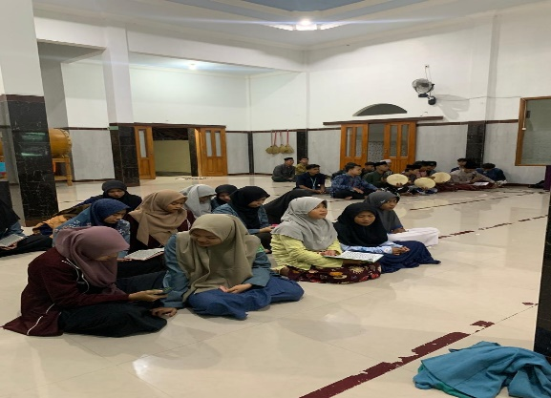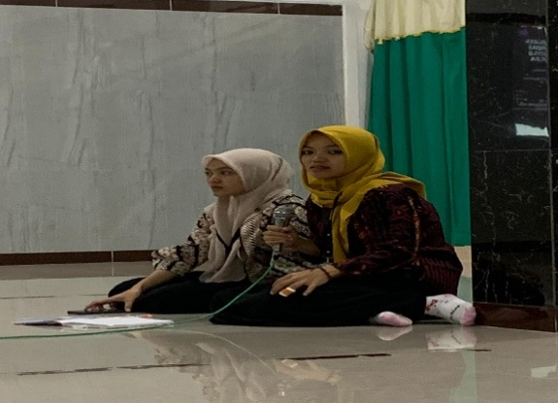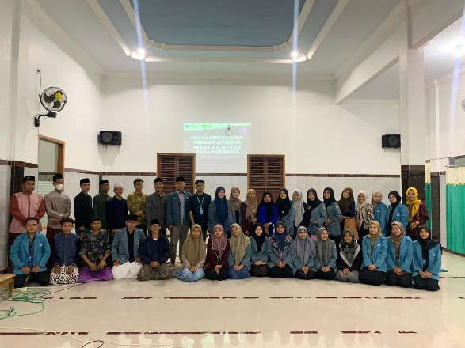 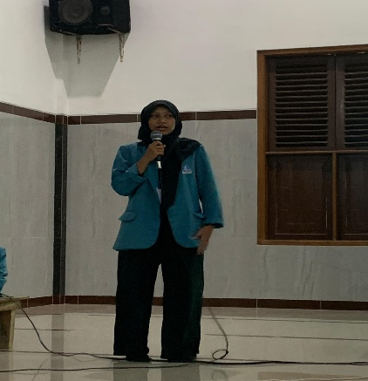

The picture above shows the atmosphere of counseling activities held in halls or meeting rooms, attended by local teenagers. In the upper left, a group of teenagers with a supervisor or committee pose for a group photo in front of the room, perhaps as documentation before or after the counseling event. In the upper right, a speaker wearing an alma mater coat can be seen giving counseling to participants. Using a microphone, the speaker stood at the front of the room and delivered educational material, emphasizing the importance of counseling in improving participants' understanding.

In the lower left picture, two speakers or administrators can be seen sitting in front of the participants. They appeared to discuss or provide explanations, which may be related to counseling themes such as prevention of promiscuity or stunting. Meanwhile, in the lower right, the participants who sat in the group, were seen focusing on taking notes or listening to the material presented. This shows that this counseling activity involves active interaction between presenters and participants, as well as encouraging youth participation to understand the material more deeply.

Overall, this picture depicts an educational and interactive atmosphere in an extension activity that aims to increase adolescents' awareness of the dangers of promiscuity and the importance of stunting prevention, in accordance with the theme "Action to Prevent Stunting Before Precarious."

**CONCLUSION**

This counseling has proven to have a positive impact on the awareness and understanding of youth and parents in Tengki Village regarding the importance of maintaining healthy associations and the role of reproductive health in preventing stunting. This education is a good foundation to prepare a healthier generation and be aware of the health risks that may arise from promiscuity

**REFERENCE**

Al-Akiti, M. A. (2016). The Revitalization of Islamic Education. Journal of Muslim Education, 41(1), 5-18.

Babatunde, S. B. A. (2020). AIH International Academy: A Model for Islamic Education. Journal of Islamic Education in Africa, 3(1), 20-35.

Hassan, M. H. (2019). Integrating Technology in Islamic Education. Journal of Technology and Islamic Education, 2(1), 15-28.

Khalil, M. H. (2017). Student-Centered Learning in Islamic Education. Journal of Islamic Education, 3(2), 10-24.

Mualimin, A. (2020). Character Development in Islamic Education. Journal of Moral Education, 49(2), 155-170.

Nasr, S. H. (2015). The Study Quran. HarperOne.

Ozsoy, S. (2018). Community Engagement in Islamic Education. Journal of Community Engagement, 2(1), 30-45.

Shah, I. A. (2019). Islamic Pedagogy: A Holistic Approach. Journal of Islamic Pedagogy, 1(1), 5-18.

Ajhuri, K. F., & Saichu, M. (2018). Pemberdayaan Taman Pendidikan Al-Quran ( TPQ ) melalui Penguatan SDM di Masjid Nurul Fikri Watu Bonang, Badegan, Ponorogo. *QALAMUNA-Jurnal Pendidikan, Sosial, Dan Agama*, *10*(2), 178. https://ejournal.insuriponorogo.ac.id/index.php/qalamuna/article/view/150/142

Helmiyati. (2021). Artikel Kesolehan Individual dan Kesolehan Sosial. *UIN Suska Riau*. https://www.uin-suska.ac.id/blog/2015/08/19/meyakini-shalat-sebagai-obat-muhammad-syafei-hasan/

Munajid, Y. S. Al. (2024). *Peran TPA dalam Meningkatkan Pemahaman Kegamaan Anak di Dusun Kemirikebo, Girikerto, Turi, Sleman*. Universitas Alma Ata Yogyakarta.

Subur, S., & Widayaiswara. (2015, July). KESOLEHAN SOSIAL BERGAMA. *Kementrian Agama BDK Banjarmasin*. https://bdkbanjarmasin.kemenag.go.id/artikel/kesolehan-sosial-bergama

Sugiyono, D. (2013). *Metode Penelitian Kuantitatif, Kualitatif, dan Tindakan*.